Using collNotes and collBook for field data collection

Introduction - “Born Digital” Natural History
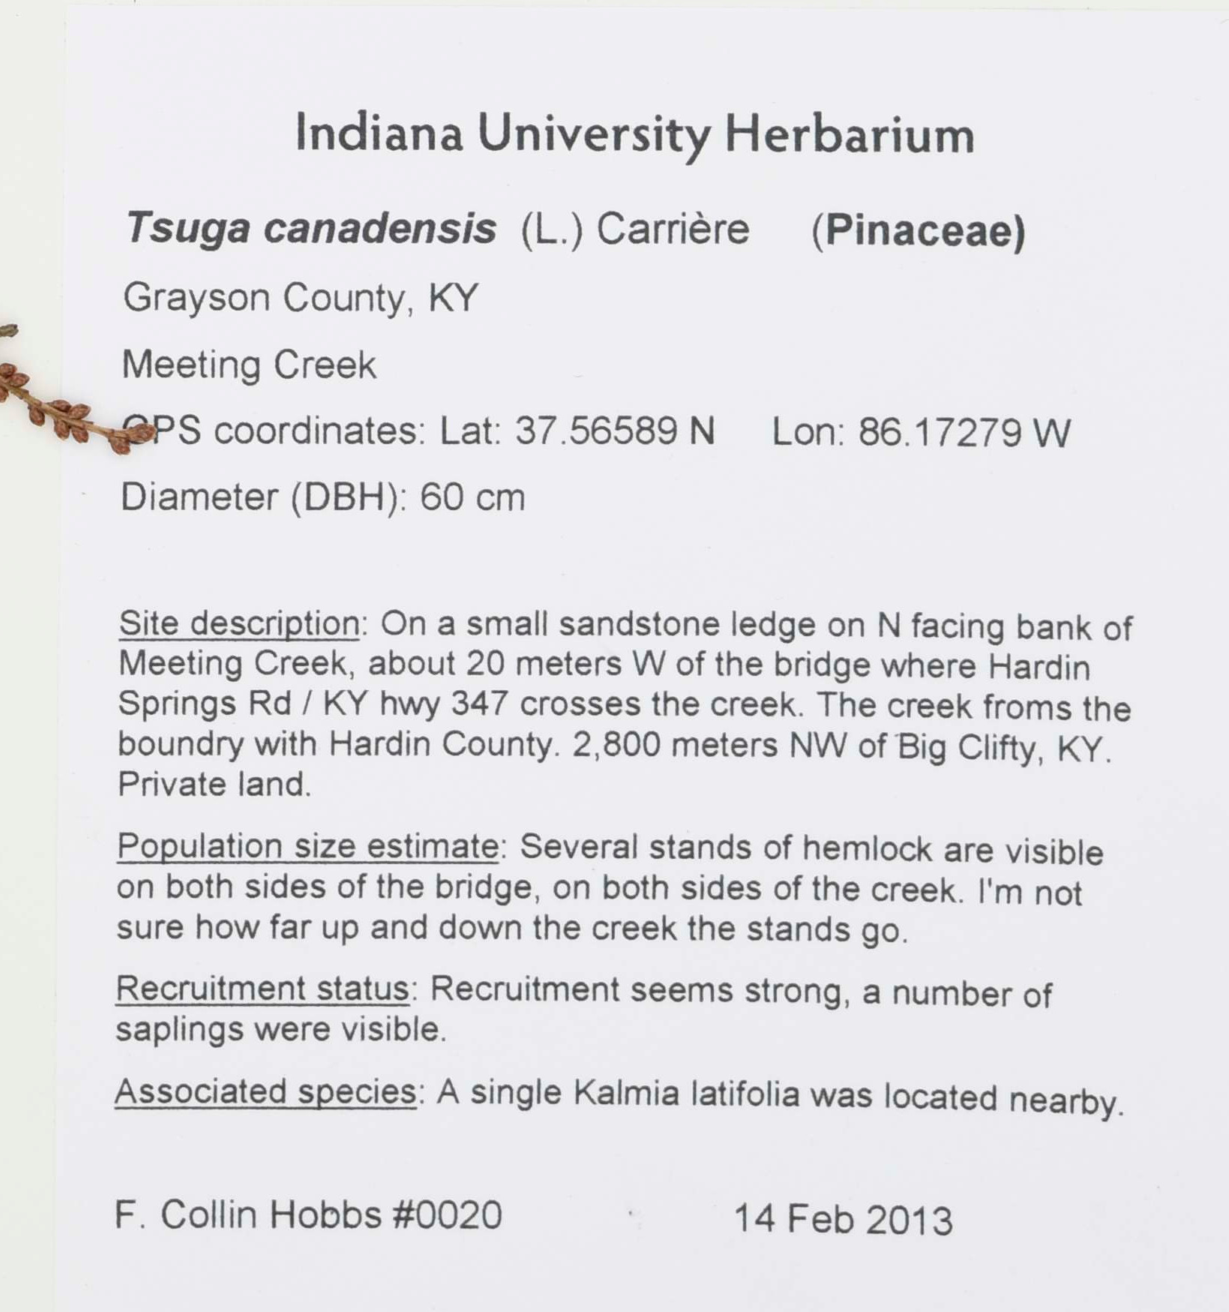Fig. 1: A data rich specimen label from the Indiana University Herbarium (catalog number: IND-0006820).
Digitized natural history collections provide millions of biodiversity records to online public portals such as GBIF, iDigBio, and SERNEC. These datasets are important resources for researchers and decision makers but keeping them up-to-date is an ongoing challenge. Much of the data associated with natural history records is initially stored as text on a specimen label (Fig. 1) which need to be transcribed for use in online portals.

collNotes and collBook have been developed to accomodate collecting “born digital” Fungi and Plantae records, which are initially gathered in digital formats suitable for online portals. To achieve this, collNotes, a mobile application, was developed to supplement the traditional field journal. A companion desktop application, collBook, enables users to refine field notes into print ready lables and portal ready comma separated value (CSV) files. Both programs have been released as open source projects, , in hopes that continued feedback and contributions from the community will improve the tools.

Getting Started – Installation & Setup

Mobile (collNotes) Installation & Equipment
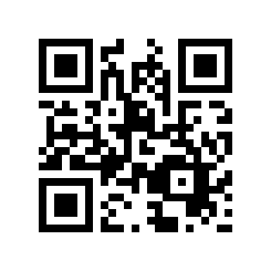Fig. 2: QR code linking to mobile application.
collNotes is a freely availble mobile application, on Android and iOS. You can find the applications in the appropriate app stores , or by following the included QR code (Fig. 2). Since GPS functionality is not dependent on cellular service, collNotes does not require a data enabled device. In addition to personal cellular devices, collNotes can also be used on a tablet. While not necessary, for extended field work it may be preferable to use a GPS enabled tablet with a rugged case, and an extended battery.

Mobile (collNotes) Initial Setup
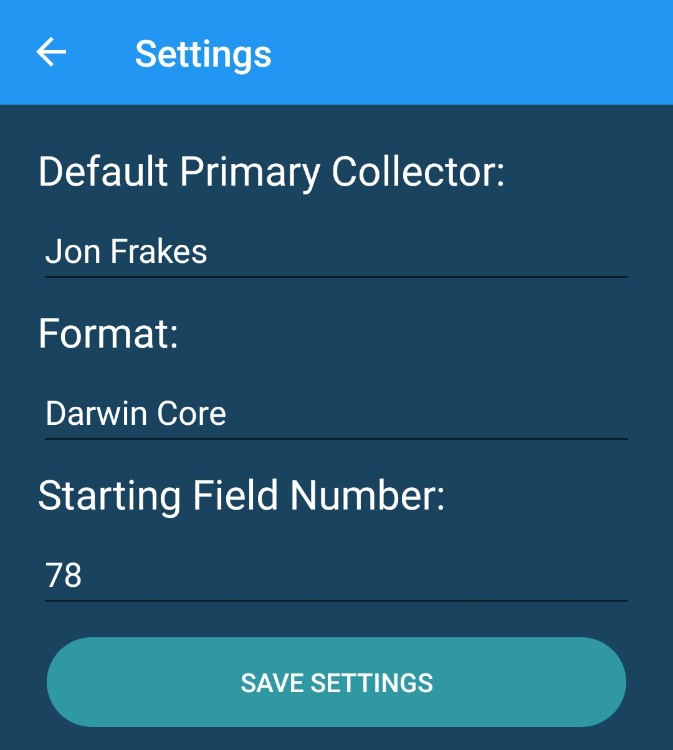Fig. 3: collNotes settings
Preferences for “default primary collector name” and “starting field number” are available in the Settings menu (Fig. 3) which is accessible from the main menu. Before using collNotes in the field it is highly reccomended to test and become familure with the program. Tests should include generating, and exporting site and specimen level records.

Desktop (collBook) Installation
collBook is available for free on Linux, OS X, and Windows. Binaries, and installation instructions are available through the project’s GitHub repository

Global Biodiversity Information Facility: https://www.gbif.org
Integrated Digitized Biocollections: https://www.idigbio.org/portal
SouthEast Regional Network of Expertise and Collections: http://sernecportal.org/portal/
collBook’s primary repository: https://github.com/CapPow/collBook
collNote’s primary repository: https://github.com/j-h-m/collNotes
Google Play store link: https://play.google.com/store/apps/details?id=com.thc.collnotes
iOS App store link: https://itunes.apple.com/US/app/id1455049130?mt=8
CollBook installation instructions: https://github.com/CapPow/collBook#installation

